
National Forensics Sciences University

School of Cyber Security and Digital Forensics

M.Tech Artificial Intelligence and Data Science (Specialization in Cyber Security)

Network Security and Forensics
Practical 1

Session 2024-25
Semester 1

Submitted To:- | Submitted By:-
Dr. Vijeta Khare | Pratham Badge

- Prerequisite
  - Search Command Prompt or cmd in windows search and open it.
or
  - Press Windows + R Keys Run will pop-up then type cmd and press ok

- How do you check the network connectivity between host and server/host.
To check the network connectivity between host and server/host:

We can use ping command :

syntax: ping [options] [hostname/IP address]

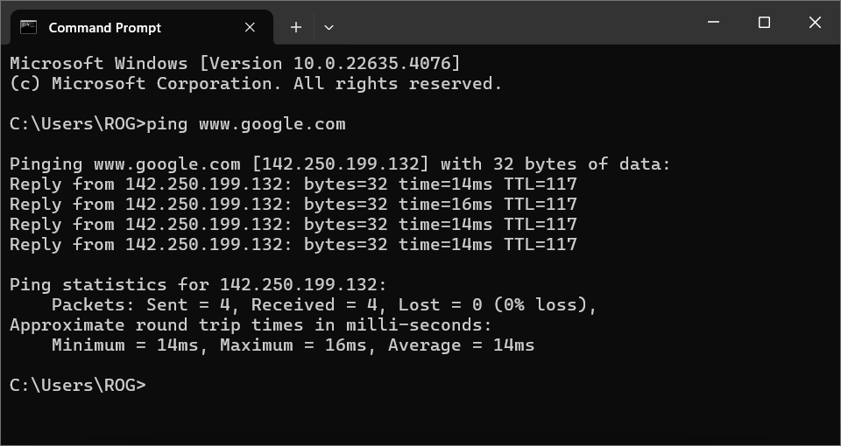

Output Explained:
It shows
- IP Address/Domain
- Packet Size of ping
- Reply Time from IP and
- Time to live of packet
- No. of packets sent, received and lost(if any)
- Max, Min and Avg Times to send and receive packets

- How to find the IP Address of your system.
To find IP Address of our system:
We can use ipconfig command:

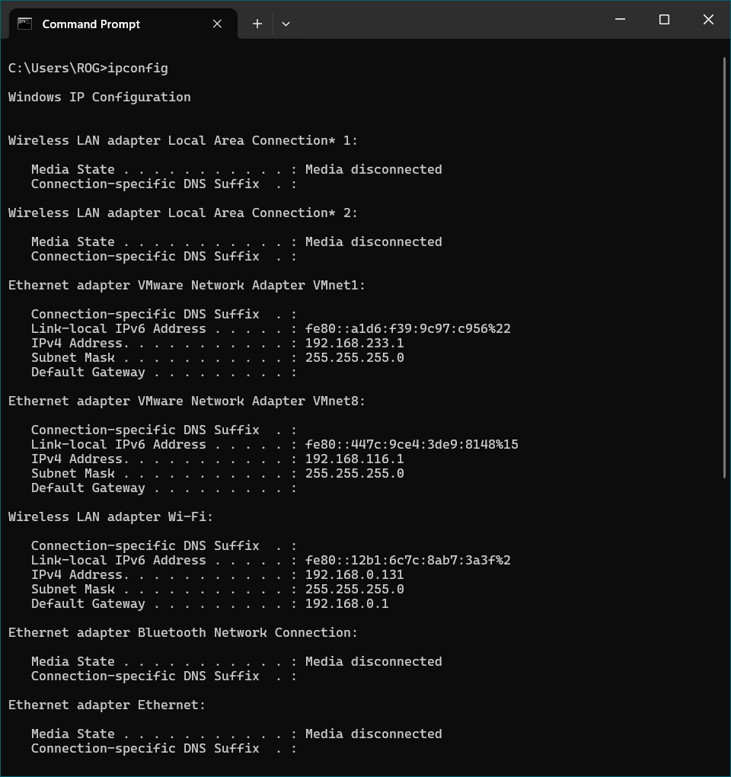

Output Explained:
It shows
- Interface Names and their status if disconnected
- IPv4 and IPv6 Addresses
- Subnet Mask
- Default Gateway

- Find MAC address from all the network cards on a system
To find MAC Address from all the network cards on a system:
We can use getmac command:

syntax: getmac [/s system [/u username [/p [password]]]] [/fo format] [/nh] [/v]

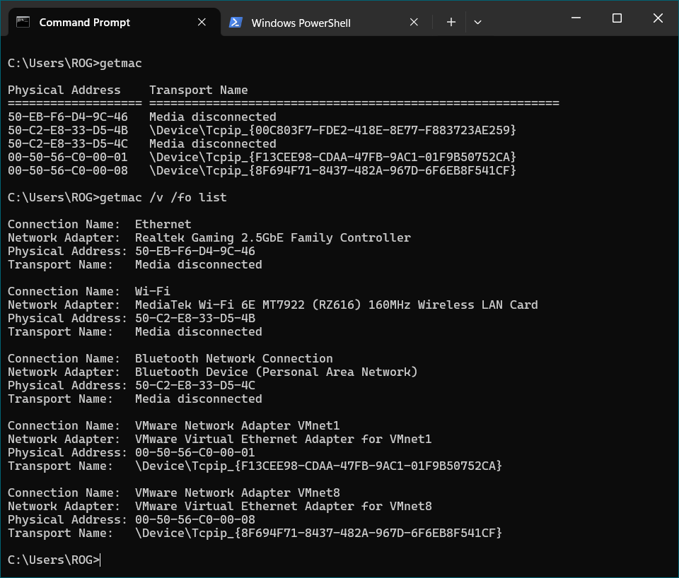

Output Explained:
It shows

i) NIC Details
ii) MAC/Physical Address of the NIC attached to the device
- How to find specification of your own system.
To find specification of your own system:
We can use systeminfo command:

Output Explained:
It shows

i) All the system information/specs of the device
ii) NIC attached to the device
iii) Details about Patch and Hotfixes

- How to find host name of your system, and what do you understand by hostname.
To find host name of your system:
We can use hostname command and by hostname we understand the name of host device in the network:

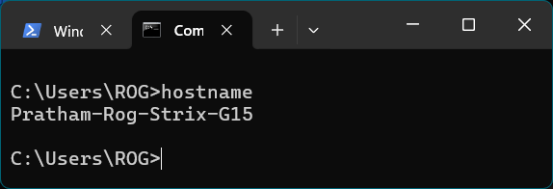

Output Explained:
It shows the host/current computer unique device identifier name

- How do you find network statistics?
To find network statistics:
We can use netstat command:

syntax: netstat [-a] [-b] [-e] [-n] [-o] [-p <Protocol>] [-r] [-s] [<interval>]

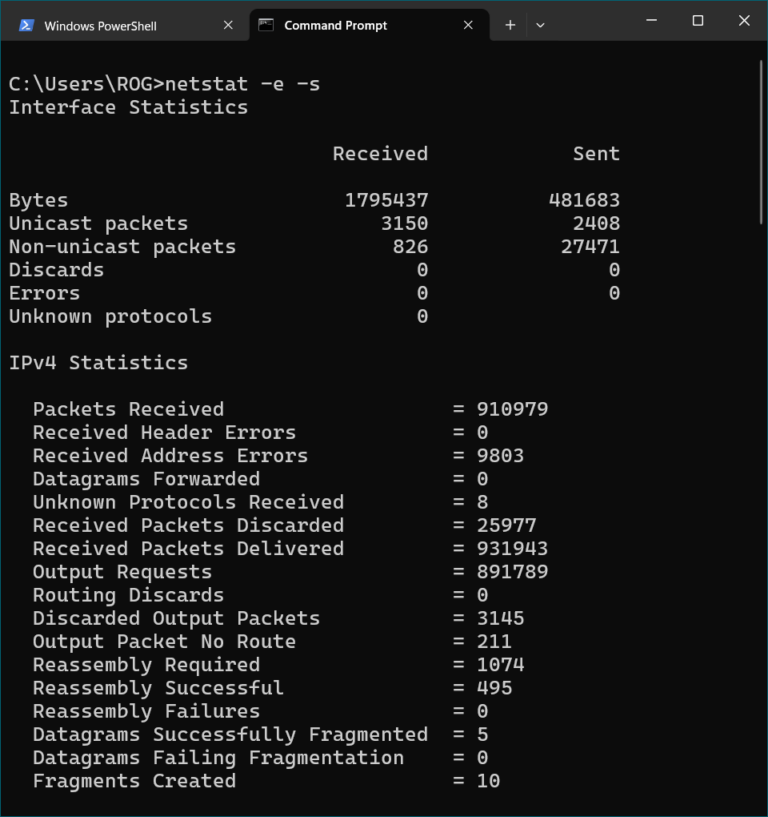

Output Explained:
It shows

i) Stats about network – Send Receive with type of protocol
ii) IPv4 Stats
- How do you trace the route that your packet has taken to reach google.com. Describe the response.
To trace the route that your packet has taken to reach google.com:
We can use tracert command:

syntax: tracert -d -h maximum_hops -j host-list -w timeout target_host

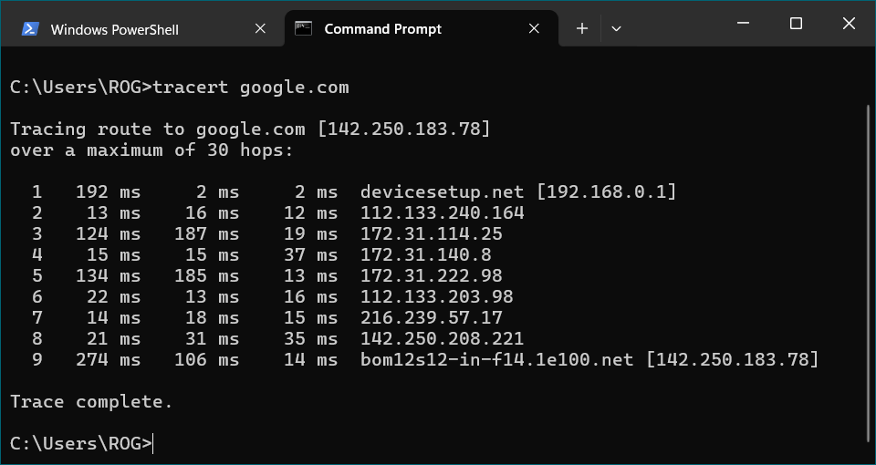

Output Explained:
It shows

i) No. of hopes to travel the destination Domain/IP
ii) 3 RTT to check consistency
iii) Domain/IP of the destination or the hop

- How do you find ip address associated with domain name?
To find IP Address associated with domain name:
We can use nslookup command:

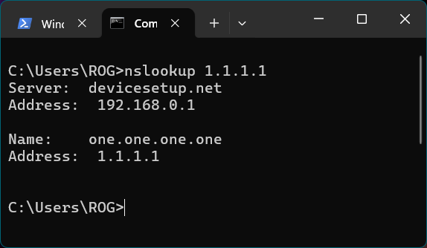

Output Explained:
It shows the Domain Name to which the specific IP address is assigned to.

- How do you access the mapping structure of IP addresses to the MAC address.

To access the mapping structure of IP addresses to the MAC address:
We can use arp command:

syntax: arp [-v] [-i if] [-H type] -a [hostname]

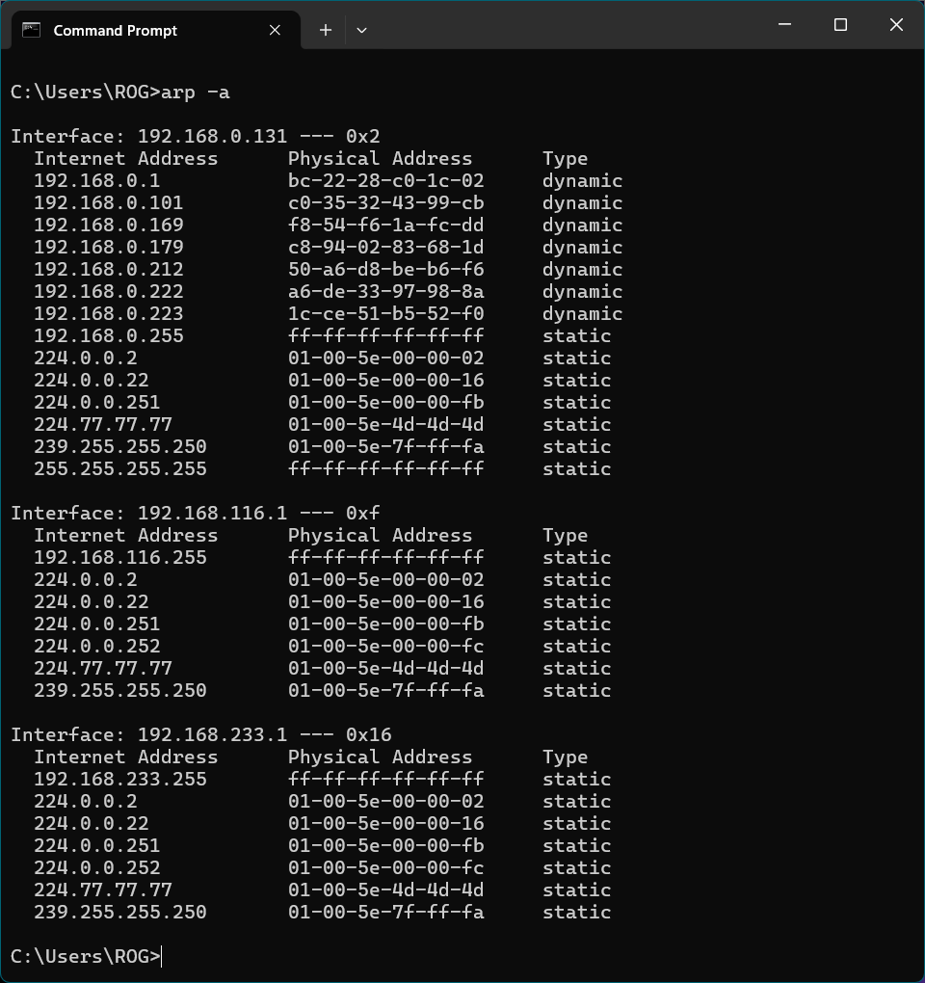

Output Explained:
It shows
i) Local IP Address
ii) Device MAC
iii) Type of connection
- How to view and manipulate the IP routing table.

To view and manipulate the IP routing table:
We can use route command:

syntax: route [/f] [/p] [<command> [<destination>] [mask <netmask>] [<gateway>] [metric <metric>]] [if <interface>]]

-f Clears the routing tables of all gateway entries. If this is
used in conjunction with one of the commands, the tables are
cleared prior to running the command.

-p When used with the ADD command, makes a route persistent across
boots of the system. By default, routes are not preserved
when the system is restarted. Ignored for all other commands,
which always affect the appropriate persistent routes.

-4 Force using IPv4.

-6 Force using IPv6.

command One of these:
PRINT Prints a route
ADD Adds a route
DELETE Deletes a route
CHANGE Modifies an existing route
destination Specifies the host.
MASK Specifies that the next parameter is the 'netmask' value.
netmask Specifies a subnet mask value for this route entry.
If not specified, it defaults to 255.255.255.255.
gateway Specifies gateway.
interface the interface number for the specified route.
METRIC specifies the metric, ie. cost for the destination.

All symbolic names used for destination are looked up in the network database
file NETWORKS. The symbolic names for gateway are looked up in the host name
database file HOSTS.

If the command is PRINT or DELETE. Destination or gateway can be a wildcard,
(wildcard is specified as a star '*'), or the gateway argument may be omitted.

If Dest contains a * or ?, it is treated as a shell pattern, and only
matching destination routes are printed. The '*' matches any string,
and '?' matches any one char. Examples: 157.*.1, 157.*, 127.*, *224*.

Pattern match is only allowed in PRINT command.
Diagnostic Notes:
Invalid MASK generates an error, that is when (DEST & MASK) != DEST.
Example> route ADD 157.0.0.0 MASK 155.0.0.0 157.55.80.1 IF 1
The route addition failed: The specified mask parameter is invalid. (Destination & Mask) != Destination.

Examples:

> route PRINT
> route PRINT -4
> route PRINT -6
> route PRINT 157* .... Only prints those matching 157*

> route ADD 157.0.0.0 MASK 255.0.0.0 157.55.80.1 METRIC 3 IF 2
destination^ ^mask ^gateway metric^ ^
Interface^
If IF is not given, it tries to find the best interface for a given
gateway.
> route ADD 3ffe::/32 3ffe::1

> route CHANGE 157.0.0.0 MASK 255.0.0.0 157.55.80.5 METRIC 2 IF 2

CHANGE is used to modify gateway and/or metric only.

> route DELETE 157.0.0.0
> route DELETE 3ffe::/32

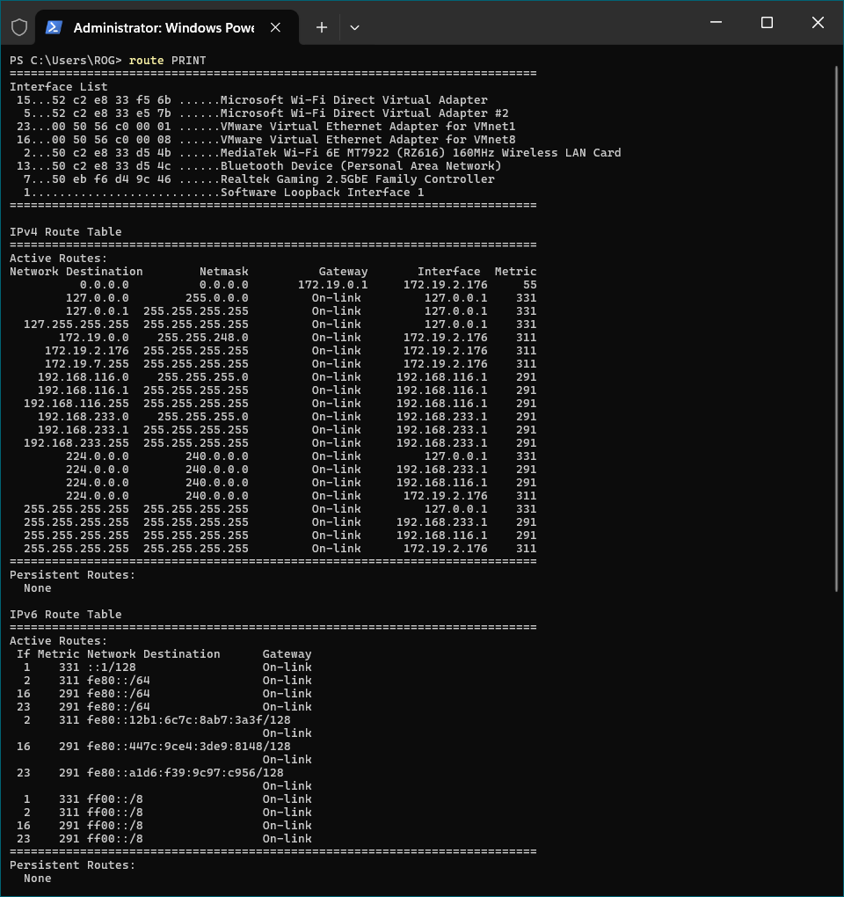

Output Explained:
It shows

i) List of NIC attached to the device
ii) IPv4 & IPv6 Route Tables

